Benny Iko

7/13/2021

SWEN 603 9040 Modern Software Methodologies

TDD methodology critique

Test Driven Development or TDD, is an Agile method, and an integral part of many iterative and incremental development methods; specifically, it is a key practice in XP. Many variants of TDD exist, and have been proposed ever since it gained popularity. Variants of TDD include behavior driven development (BDD) and acceptance test driven development (ATDD). Kent Beck created Test Driven Development in 2003, and stated that it inspires confidence and promotes simple designs. Since TDD is a test first development approach, there is a greater emphasis placed on building well tested software applications. To accomplish this feat, this software development process greatly relies on repetition; it is a very brief development cycle, and can be described accurately by its mantra red/green/refactor. Precisely, the first step is to fail test cases. Next, is to pass the test cases, and then to refactor code accordingly. This allows developers to write code relating to the solution of the defined tasks in the tests after a well thought out process. Most tests are written before the code to be tested, providing many benefits for developers. TDD test cases are prepared with the aid of user stories or use cases of the software application being developed. Implementing TDD ensures that all code is covered by at least one test. For instance, just the simple fact that tests are written is a practical consequence. This provides obvious benefits in comparison to projects that do not produce tests. Also, by writing tests first, the developer must think critically about public behavior of an unwritten class. This helps to clarify behavior and design of a class before implementation, thus improving design. In a field where time and money are often wasted, a 2005 study of TDD found interesting results about productivity. The utilization of TDD means more tests are written, but less obviously, programmers who wrote more tests tended to be more productive.

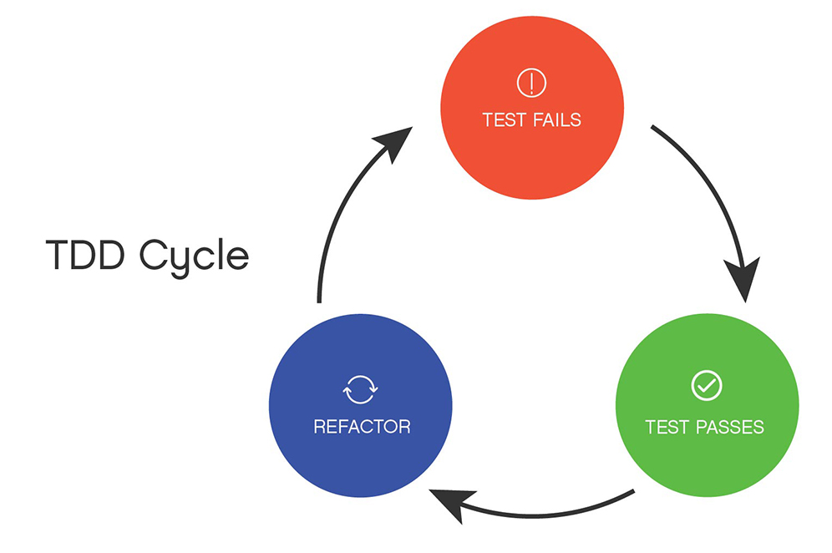

TDD is easily recognized by its best practices and anti-patterns. In my opinion, the most notable best practice relates directly to the code. It states: “Treat your test code with the same respect as your production code. It also must work correctly for both positive and negative cases, last a long time, and be readable and maintainable.” This places an extra emphasis on the production and presentation of the often overlooked task of testing. While Test Driven Development offers validation, one would be remiss not to see other positive qualities. This method can guide the design of a program. The functionality and how client usage is envisioned well before any coding takes place. The interface is conceptualized well before the implementation. This aligns well with Agile values, as it is complementary to other methods and approaches code through test cases instead of preconceptions.

TDD, like other methodologies, is not without its misconceptions or flaws. This style of software management is susceptible to creating a false sense of security. If there are a high number of passing tests, this could result in fewer testing activities. These tests require maintenance, and since there is such an uptick in test volume, it adds a lot of overhead to a project. Moreso, overtesting can be a problem and may become time consuming as well. These tests may need to be modified if and when requirements change. TDD relies on unit testing and does not perform enough testing in areas where functional tests are required to determine failure or success. A common misconception of the practice is that tests cannot be written until the design is determined. On the contrary, TDD facilitates the institution of a clear cut plan to implement code, resulting in a proper design. Another misconception is that tests must be written to completion, before writing code. Conversely, TDD favors exploratory processes; it is possible to write tests and just enough code to pass, then the developer is able to move onto another feature.

Due to the nature of Test Driven Development, I believe this software life cycle is well suited for mission critical and real time applications. Any software that is produced using this management style will be well tested. Also, this style is well suited for large teams, making it appropriate for companies such as Boeing, Nasa, and Northrop Grumman. Moreover, I believe this style is perfect for complex applications, because so much focus is placed on the modules; that is, the interface. It seems like it would also make the tasks of integration simpler. I think I will actually like to practice creating software in this style as well. While looking for my article to post, I found a book entitled C# and .NET Core Test-Driven Development. These are languages that are essential for creating a game using the Unity framework and I’m hoping to learn a lot from reading.

